**How to Reduce SSISDB Size**

**Problem**: SSISDB is growing and it reached size 94 GB and started causing package deadlock, and heating package performance.

SSIS projects, packages, parameters, environments, and operational history are all stored in the SSISDB database so if you have hundreds of SSIS packages or packages that run every few minutes you could see how the database storing all the historical information would grow exponentially.

**Solution:** SSISDB is used to store the package log and configuration information, so whenever package will get deploy or execute it will store the version information and also the details of every execution of package. So if your package execution frequency is very high then this DB will grow very quickly.

   To clean the old log information from this database SQL server provides job called “**SSIS Server Maintenance Job**” to clean the SSISDB old records. Default schedule of this Job is to execute every night at 12 O’clock  once. This Job will call the procedure “EXEC **SSISDB.[internal].[cleanup_server_retention_window]**”  and this procedure will delete 10-10 records as batch and as per **retention** values that is specified in the “select * from [SSISDB].[catalog].[catalog_properties]” table. RETENTION value will define how much older data we have to keep in the SSISDB. Default values is 365 i.e.1 year.

You can also see that the stored procedure queries catalog.catalog_properties to find these values. Let’s take a look at catalog_properties:

|  |
| --- |
| SELECT * FROM [catalog].[catalog_properties] |

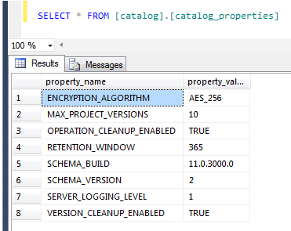

Operation_Cleanup_Enabled is set to TRUE meaning that the package will cleanup and Retention_Window is set to 365 meaning that the package will cleanup history, etc. if it’s older than 365 days.

To change the retention value, first you need to determine how many days you would like to keep in history, then we can run the catalog.configure_catalog stored procedure to change this value. For my example, I’ll change to 150 because I don’t need to keep anything past 150 days:

|  |
| --- |
| SELECT [property_name],[property_value] FROM [SSISDB].[internal].[catalog_properties]  EXEC catalog.configure_catalog RESTENSION_WINDOW,150 |